GUARDIAN AI
BRAND BIBLE

The definitive guide to our identity, voice, and visual language.

“Your brand is what other people say about you when you're not in the room.”

— Jeff Bezos

Contents
What's Inside

01 | Brand Foundation | Who we are, what we stand for, mission, vision, positioning, and core values
02 | Logo System | Logo structure, meaning, clear-space rules, usage guidelines, and restrictions
03 | Colour Palette | Core navy palette, extended UI colours, neutrals, gradients, and usage rules
04 | Typography | Font system, hierarchy, type scale, and typography principles.
05 | Brand Voice & Tone | Communication style, tone guidelines, voice matrix, and words to avoid.
06 | Imagery & Iconography | Photography direction, visual style, and icon design system
07 | Presentation Guidelines | Slide design rules, layouts, grid system, and presentation structure
08 | Brand in Use | Real-world application rules.
09 | What Not to Do | Common mistakes and how to avoid them.
10 | Brand Principles | core philosophy behind design decisions — clarity, consistency, and control

01 — Brand Foundation
Who We Are

Guardian AI is an enterprise AI platform built to help organizations operate with confidence, clarity, and control.
🛡️ We Are The Intelligent Protectors
We empower businesses to:
- Protect their digital systems
- Make accurate decisions
- Act in real-time
Mission
To give enterprises the intelligence they need to protect, decide, and act — with precision and without compromise.
Vision
A world where organisations of any scale can operate with the confidence of an AI-powered guardian by their side — watching, learning, and acting on their behalf.

We are the system that watches, understands, and protects — continuously.

WHAT MAKES US UNIQUE

Guardian AI is designed for organizations that cannot afford to be wrong. Unlike traditional tools, we don’t just provide data —
👉 we deliver intelligence that drives action.
⚡ We Are Not a Tool — We Are a System of Intelligence
Positioning
Guardian AI is the enterprise artificial intelligence platform built for organisations that cannot afford to be wrong. We are not a tool. We are a system of intelligence — built for scale, designed for trust.
Core Values
Authority | Precision | Trust | Intelligence
We speak with certainty. Our design carries weight. | Every element is deliberate. No noise. No waste. | Enterprise clients entrust us with critical systems. | We signal advanced capability without gimmick.
We don’t just analyze — we enable confident action.
02 — Logo System
The Mark

The Guardian AI logo is built from two core elements:
- Shield Mark — representing protection and structure
- Wordmark — representing authority and trust
Primary Lockup


These elements are locked together and should always be used as one unit to maintain consistency.

Meaning Behind the Logo

The Guardian AI logo combines protection, intelligence, and trust into one unified identity. The shield represents security and reliability, while the precision reticle inside reflects real-time monitoring and smart decision-making. The wordmark adds authority and professionalism, giving the brand a strong enterprise presence.
Together, the logo communicates a system that not only protects but also thinks, monitors, and acts intelligently.

Clear-space Rule
Maintain a minimum clear-space equal to the cap-height of the letter 'G' in GUARDIAN on all four sides. No text, icons, or graphic elements may enter this zone.
Approved Background Uses

Background | Logo Variant | Notes
Dark / Navy | Primary (navy wordmark, blue shield) | Preferred usage
White / Light | Reversed (navy on light) | Maintain contrast ≥ 4.5:1
Photography | White wordmark + shield | Dark-area photos only
Single colour | Monochrome navy | Print, emboss, single-ink

Logo Don’t

What Not To Do
To maintain a strong and consistent brand identity, the Guardian AI logo must always be used correctly. Any misuse can reduce clarity, professionalism, and trust.
Common Mistakes to Avoid
- Do not stretch or distort the logo
→ Always maintain original proportions
- Do not change colours outside the approved palette
→ Use only official brand colours
- Do not add effects like shadows, glow, or gradients
→ Keep the logo clean and minimal
- Do not recreate or change the font
→ Always use the original wordmark
- Do not place on cluttered or low-contrast backgrounds
→ Ensure the logo is always clearly visible
- Do not separate or rearrange elements
→ Shield and wordmark must stay together
- Do not resize elements independently
→ Scale the logo as one unit

Why This Matters
Even small changes can:
- Reduce brand recognition
- Make the design look unprofessional
- Break visual consistency across platforms
Our logo is carefully designed and consistently used to reflect trust, intelligence, and protection across every touchpoint.

03 — Colour Palette
Navy Blue System

Guardian AI is built on a single-family navy-blue palette, designed to create a strong, consistent, and premium identity across all platforms.
From deep navy tones to bright cyan highlights, each colour plays a specific functional role — ensuring clarity, hierarchy, and visual control.
👉 Restraint is the strategy: one colour family, total mastery.
The Five Blues

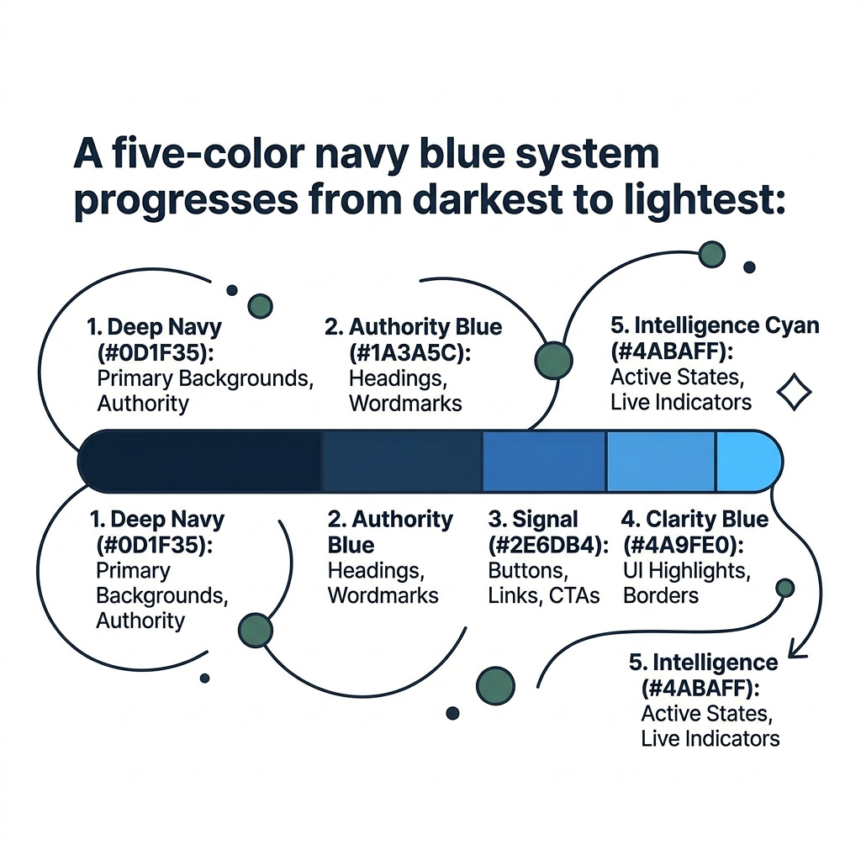
- Deep Navy - #0D1F35 (RGB: 13,31,53): The foundation of the brand. Used for primary backgrounds, cover surfaces, and dominant UI areas. It creates a sense of depth, security, and authority.
- Authority Blue — #1A3A5C (RGB: 26, 58, 92): The main brand colour used for headings, wordmarks, and structured content. It reinforces a strong and professional presence.
- Signal Blue — #2E6DB4 (RGB: 46, 109, 180): The action colour of the system. Used for buttons, links, and call-to-actions, guiding user interaction and attention.
- Clarity Blue — #4A9FE0 (RGB: 74, 159, 224): Used for UI highlights, borders, and dividers. It improves structure and visual clarity without overwhelming the interface.
- Intelligence Cyan — #4ABAFF (RGB: 74, 186, 255): The most dynamic colour in the palette. Used for active states, live indicators, and glow effects, representing real-time intelligence and activity.
Extended UI Layer (Functional Colours)
To support the core palette in digital products, additional dark tones are used:

Swatch | Name | Hex | RGB | Usage
 | Deep Background | HEX  #020617 | RGB  2, 6, 23 | Main app background
 | Soft Navy | HEX  #0B1F3A | RGB  11, 31, 58 | Section layering
 | Card Surface | HEX  #0F172A | RGB  15, 23, 42 | Cards and containers
 | Border | HEX  #1E293B | RGB  30, 41, 59 | Dividers and outlines
These ensure depth, structure, and usability in UI design.

Neutral Companions
These neutrals exist to support the blues — never to compete with them.

Swatch | Name | Hex | RGB | Usage
 | Near Black | HEX  #0A0F1A | RGB  10, 15, 26 | Body text on light backgrounds
 | Charcoal | HEX  #1E2A38 | RGB  30, 42, 56 | Primary body copy
 | Slate | HEX  #4A5568 | RGB  74, 85, 104 | Secondary text, captions
 | Frost | HEX  #EBF3FB | RGB  235, 243, 251 | Card backgrounds, table rows
 | Mist | HEX  #F0F5FC | RGB  240, 245, 252 | Page backgrounds
 | Pure White | HEX  #FFFFFF | RGB  255, 255, 255 | Clean surfaces, reversed text

Gradient System
Guardian AI uses a cyan-to-blue gradient to introduce motion and emphasis in key areas.

Used for:
- Hero sections
- Highlights
- Interactive visuals

Colour Pairing Rules
- Deep Navy + Intelligence Cyan = primary hero combination.
- Authority Blue + Pure White = standard document default.
- Never pair two similar blues at the same visual weight — always create contrast.
- Frost and Mist are background-only — never use as text colour.
- Minimum contrast ratio for all text: WCAG AA (4.5:1).
👉 Every colour in Guardian AI is functional — designed to enhance clarity, guide attention, and build trust.

04 — Typography
Type System

Guardian AI uses a dual typeface system. A high-contrast serif commands authority at display sizes. A geometric sans-serif delivers clarity in body copy and UI. The interplay between them is the brand's typographic signature.

Primary Typefaces

DISPLAY  Georgia  Cormorant Garamond  Logo wordmark, hero headlines, and all display-scale text. High contrast. Commands attention. | BODY & UI  Calibri  Barlow / Rajdhani  Body copy, UI labels, data tables, captions, and sub-labels. Optimised for legibility at small sizes.

Type Scale

Level | Size | Weight | Usage
Hero / Cover Headline | 48–72pt | Bold | Cover pages, campaign hero text
Section Head H1 | 36pt | Bold | Major section openers
Sub-Heading H2 | 24pt | Bold | Sub-sections within chapters
Topic Head H3 | 18pt | SemiBold | Topic introductions
Body Copy | 11pt | Regular | All running text and paragraphs
Caption / Tag | 8–9pt | Regular | Tags, table headers, footnotes

Typography Principles

- Maintain clear visual hierarchy at all times
- Use serif fonts only for display and emphasis
- Use sans-serif fonts for all functional content
- Avoid mixing fonts randomly — follow defined roles
- Keep spacing, alignment, and scale consistent

05 — Brand Voice & Tone
How We Speak

Guardian AI's voice is the written equivalent of its visual identity: calm authority. We do not shout. We do not oversell. We state. We demonstrate. Every word earns its place.

Voice Matrix

We Are | We Are Not | We Never Say
Precise | Vague | Revolutionary
Authoritative | Aggressive | Game-changing
Direct | Casual | Best-in-class
Trusted | Cold | Disruptive
Intelligent | Boastful | Next-generation
Composed | Robotic | Cutting-edge

What We Avoid  To maintain a strong and professional identity, we never:  - Use vague or unclear language  - Sound aggressive or overly promotional  - Overpromise or exaggerate capabilities  - Use trendy buzzwords or hype-driven phrases  - Sound robotic or emotionless  Our tone is human, but always controlled and intentional. | Words We Never Use  Certain words weaken credibility and must be avoided:  - “Revolutionary”  - “Game-changing”  - “Best-in-class”  - “Disruptive”  - “Next-generation”  - “Cutting-edge”  Let the product prove intelligence — don’t claim it.

Tone by Context

Context | Tone | Example
Product UI | Concise, calm, instructive | "Scan complete. 3 anomalies flagged."
Marketing copy | Confident, benefit-led | "Intelligence that never sleeps."
Error messages | Clear, non-alarmist, actionable | "Connection lost. Retrying in 5 seconds."
Executive reports | Formal, data-grounded | "Q3 performance exceeded benchmark by 18%."
Support comms | Helpful, measured, respectful | "Your request has been escalated to our team."

06 — Imagery & Iconography
Visual Language

Photography Direction
Guardian AI imagery should feel precise, purposeful, and human. Technology shown in service of real decisions — not abstract visualizations for their own sake.

Use  - Dark, high-contrast environments  - Decisive human moments — command centres, boardrooms  - Close-up precision: hands, screens, data  - Desaturated palettes with blue accent lighting  - Confident body language — never panic or chaos | Avoid  - Generic bright stock photography  - Abstract AI clichés — robot hands, glowing brains  - Overlit corporate handshake imagery  - Clipart or flat illustrated scenes  - Anything that looks like a startup or consumer app

Icon Style
- Grid: 24×24px base, 2px padding.
- Stroke: 1.5px, rounded cap and join, no fill.
- Color: Signal Blue (#2E6DB4) on light; Clarity Blue (#4A9FE0) on dark.
- Export: SVG + PNG @2x for all icons.

07 —PRESENTATION GUIDELINES
Cover Slide Guidelines

The cover slide sets the tone for every Guardian AI presentation. It must be bold, minimal, and unmistakably on-brand.

Regular Slide Guidelines

Every content slide follows a disciplined grid. One key message per slide. No walls of text. Structure creates clarity.

Layout Rules
- Background: White or Mist #F0F5FC for content slides
- Headline: Authority Blue #1A3A5C, H1 at 36pt Bold
- Body text: Charcoal #1E2A38, Calibri 11pt Regular
- Dividers: Clarity Blue #4A9FE0, 1px rule
- Logo: Header or footer, 120px wide, navy variant
- Charts: Five-blue palette only — no external colors
Grid: Use a 12-column grid. Maintain 48px margins on all sides. Align all elements to the grid.

Grid & Layout Example
Consistent grid structure ensures every slide feels intentional. Use these three core layouts as your default starting points.

What Not to DO

Brand consistency is built as much by knowing what to avoid as by knowing what to use.

 | The Mistake | The Correct Approach
1 | Using colours outside the brand palette | Use only the five approved blues and neutral companions
2 | Adding AI buzzwords or hype language | Let the product demonstrate intelligence — avoid claims
3 | Mixing fonts randomly | Follow the defined typography hierarchy
4 | Stretching, recoloring, or modifying the logo | Always use approved logo files without changes
5 | Using casual or inconsistent tone | Match communication with brand voice guidelines
6 | Low contrast text combinations | Maintain WCAG AA standard (minimum 4.5:1)
7 | Crowding the logo with other elements | Always respect the clearspace rule
8 | Using Frost or Mist as text color | Use Charcoal or Navy for all readable text

08 — Brand in Use
Applications

Digital — Product UI
- Use Deep Navy (#0D1F35) as the primary dark-mode background.
- Signal Blue (#2E6DB4) for all interactive and clickable elements.
- Intelligence Cyan (#4ABAFF) for active states and live indicators.
- All text must meet WCAG AA minimum contrast ratio (4.5:1).
- Calibri or Barlow for all UI text — no display serif in product UI.
Documents & Reports
- Cover pages: Navy background, white wordmark, Signal Blue accent bar.
- Body pages: White or Mist background, Navy headings, Signal Blue markers.
- All official documents must carry the logo on the cover or header.
- Data tables use Frost (#EBF3FB) alternating rows for legibility.
Presentations
- Title slides: Deep Navy background, white headline, sky blue accent.
- Content slides: White background with navy structure and blue dividers.
- One key message per slide — no walls of text.
- Charts use the five-blue palette only. No other colors introduced.
Email & Correspondence
- Signature: Name, title, Guardian AI — logo at 120px wide.
- Body: Calibri 11pt, navy headings if needed, no decorative fonts.
- Subject lines: Title case. Direct. No hype.

09 — What Not to Do
Common Mistakes

Brand consistency is built as much by knowing what to avoid as by knowing what to use. These are the most common errors made with the Guardian AI identity.

 | The Mistake | The Correct Approach
1 | Introducing colours outside the navy palette | Use only the five approved blues and their neutral companions.
2 | Adding AI buzzwords to copy | Let the product demonstrate intelligence. Don't claim it.
3 | Mixing display and body fonts arbitrarily | Follow the type hierarchy. Each level has a defined role.
4 | Stretching or recolouring the logo | Only ever use approved logo files. Never alter them.
5 | Casual tone in formal materials | Match tone to context (see Section 05).
6 | Low-contrast text combinations | Verify WCAG AA compliance before publishing anything.
7 | Crowding the logo with other elements | Respect the clear-space rule at all times.
8 | Using Frost or Mist as a text colour | These shades are background-only. Use Charcoal or Navy for text.

10 — Brand Principles
The Foundation Behind Every Decision

Guardian AI is not just about how we look — it’s about how we think, design, and communicate.
These principles guide every product, design, and interaction.

Six Principles. One Purpose
Every decision we make — in product, design, and communication — is anchored to these six principles. Together, they define what Guardian AI stands for and how we show up for the organisations we serve.

01 | Clarity Drives Decisions | Our role is to remove uncertainty.
02 | Trust Is Our Foundation | We operate in environments where mistakes are costly.
03 | Intelligence Must Lead to Action | We don’t just provide data — we enable action.
04 | Precision at Scale | Our systems are built for enterprises that cannot afford errors.
05 | Control Without Complexity | We give organisations powerful capabilities without overwhelming them..
06 | Authority Through Discipline | Our brand reflects the seriousness of what we do.

Our Core Statement
"Guardian AI exists to deliver intelligence that organisations can trust — to protect, decide, and act without compromise."
These six principles are the foundation of everything we build. They are not a checklist — they are a commitment to the organisations that depend on us.

GUARDIAN AI
Brand Bible · Version 2.0 · Confidential

